**JUNAID GIRKAR**

**60004190057**

**TE COMPS A4**

**DWM**

**EXPERIMENT 5**

**AIM**: Implementation of Association rule mining Using

1. Apriori Algorithm

2. FPTree

**THEORY**:

Association rule learning is a type of unsupervised learning technique that checks for the dependency of one data item on another data item and maps accordingly so that it can be more profitable. It tries to find some interesting relations or associations among the variables of the dataset. It is based on different rules to discover the interesting relations between variables in the database.

The association rule learning is one of the very important concepts of machine learning, and it is employed in Market Basket analysis, Web usage mining, continuous production, etc. Here market basket analysis is a technique used by the various big retailers to discover the associations between items.

Association rules are created by thoroughly analyzing data and looking for frequent if/then patterns. Then, depending on the following two parameters, the important relationships are observed:

1. Support: Support indicates how frequently the if/then relationship appears in the database.
2. Confidence: Confidence tells about the number of times these relationships have been found to be true.

**CODE**:  
**Apriori**

| import pandas as pd import numpy as np import math  transaction_df = pd.read_csv('GroceryStoreDataSet.csv') transaction_df  transaction_df.index.rename('TID', inplace=True) transaction_df.rename(columns={'MILK,BREAD,BISCUIT' : 'item_list'}, inplace=True)  trans_df = transaction_df.item_list.str.split(',') trans_df  def prune(data,supp):    df = data[data.supp_count >= supp]   return df   def count_itemset(transaction_df, itemsets):    count_item = {}  for item_set in itemsets:  set_A = set(item_set)  for row in trans_df:  set_B = set(row)    if set_B.intersection(set_A) == set_A:   if item_set in count_item.keys():  count_item[item_set] += 1    else:  count_item[item_set] = 1    data = pd.DataFrame()  data['item_sets'] = count_item.keys()  data['supp_count'] = count_item.values()    return data  def count_item(trans_items):    count_ind_item = {}  for row in trans_items:  for i in range(len(row)):  if row[i] in count_ind_item.keys():  count_ind_item[row[i]] += 1  else:  count_ind_item[row[i]] = 1    data = pd.DataFrame()  data['item_sets'] = count_ind_item.keys()  data['supp_count'] = count_ind_item.values()  data = data.sort_values('item_sets')  return data   def join(list_of_items):  itemsets = []  i = 1  for entry in list_of_items:  proceding_items = list_of_items[i:]  for item in proceding_items:  if(type(item) is str):  if entry != item:  tuples = (entry, item)  itemsets.append(tuples)  else:  if entry[0:-1] == item[0:-1]:  tuples = entry+item[1:]  itemsets.append(tuples)  i = i+1  if(len(itemsets) == 0):  return None  return itemsets  def apriori(trans_data,supp=3, con=0.5):  freq = pd.DataFrame()    df = count_item(trans_data)    while(len(df) != 0):    df = prune(df, supp)    if len(df) > 1 or (len(df) == 1 and int(df.supp_count >= supp)):  freq = df    itemsets = join(df.item_sets)    if(itemsets is None):  return freq    df = count_itemset(trans_data, itemsets)  return df  freq_item_sets = apriori(trans_df, 5) freq_item_sets  def calculate_conf(value1, value2):  return round(int(value1)/int(value2) * 100, 2)  def strong_rules(freq_item_sets, threshold):   confidences = {}  for row in freq_item_sets.item_sets:  for i in range(len(row)):  for j in range(len(row)):  if i != j:  tuples = (row[i], row[j])  conf = calculate_conf(freq_item_sets[freq_item_sets.item_sets == row].supp_count, count_item(trans_df)[count_item(trans_df).item_sets == row[i]].supp_count)  confidences[tuples] = conf     conf_df = pd.DataFrame()  conf_df['item_set'] = confidences.keys()  conf_df['confidence'] = confidences.values()   return conf_df[conf_df.confidence >= threshold]  confidence_threshold = int(input()) #50 strong_rules(freq_item_sets, threshold=confidence_threshold)   # ### Rules with confidence level >= 50.0%  from functools import reduce import operator  def interesting_rules(freq_item_sets):    lifts = {}  prob_of_items = []    for row in freq_item_sets.item_sets:  num_of_items = len(row)    prob_all = freq_item_sets[freq_item_sets.item_sets == row].supp_count / 18  for i in range(num_of_items):  prob_of_items.append(count_item(trans_df)[count_item(trans_df).item_sets == row[i]].supp_count / 18)    lifts[row] = round(float(prob_all / reduce(operator.mul, (np.array(prob_of_items)), 1)), 2)    prob_of_items = []      lifts_df = pd.DataFrame()  lifts_df['Rules'] = lifts.keys()  lifts_df['lift'] = lifts.values()    return lifts_df  int_rules = interesting_rules(freq_item_sets) int_rules |
| --- |

**OUTPUT**:

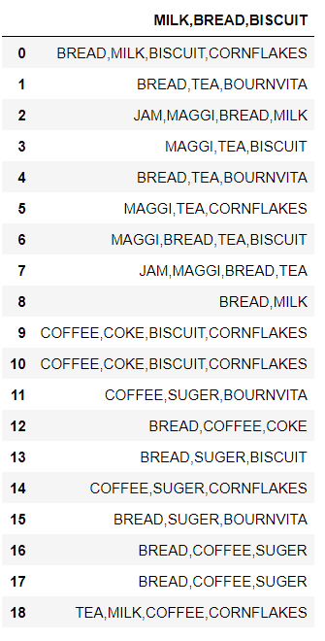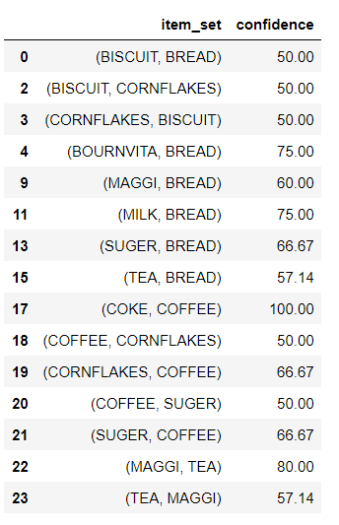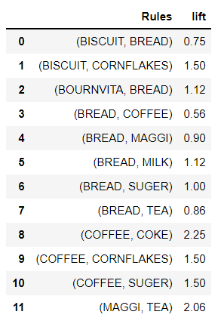

**FP TREE**

**CODE**:

| import pandas as pd from mlxtend.preprocessing import TransactionEncoder from mlxtend.frequent_patterns import fpgrowth dataset = [['f', 'a', 'c', 'd', 'g', 'i', 'm', 'p'],  ['a', 'b', 'c', 'f', 'l', 'm', 'o'],  ['b', 'f', 'h', 'j', 'o', 'w'],  ['b', 'c', 'k', 's', 'p'],  ['a', 'f', 'c', 'e', 'l', 'p', 'm', 'n']]   te = TransactionEncoder() te_ary = te.fit(dataset).transform(dataset) df = pd.DataFrame(te_ary, columns=te.columns_) df fpgrowth(df, min_support=0.6, use_colnames=True, verbose=2) # 3/5 = 60% |
| --- |

OUTPUT: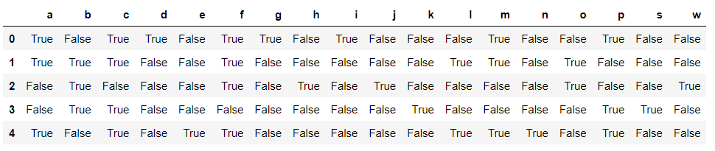

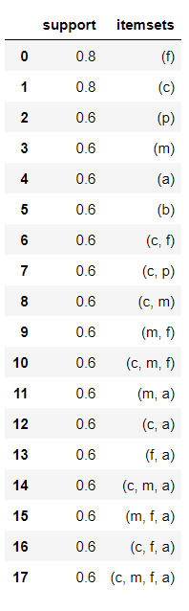

**CONCLUSION:** We learnt about association rule mining and the two different algorithms that can be used - Apriori and FP Tree. We then learn about the uses of this algorithm and implemented the algorithm in a python program.